Advance Database Concepts

Report

Wing Keung Wong 301242732

Ho Yin Wong 301290744

Tsang Noah Wai Ching 30123353

FunctionX System

Type of Business : Foreign currencies exchange system

Problem Domain Description:

Foreign currency exchange is a financial domain that involves the conversion of one currency into another currency at an agreed exchange rate. PL/SQL (Procedural Language/Structured Query Language) is a programming language that is used to manage and manipulate data in a relational database.

In this problem domain, PL/SQL can be used to develop a system for foreign currency exchange. The system can include tables for storing currency exchange rates, customer information, and transaction history. The system can also have functions and procedures for calculating exchange rates, processing transactions, and generating reports.

The following are some of the key features that can be included in the system:

1. Currency exchange rate management: The system can include a table that stores the exchange rates between different currencies. This table can be updated periodically to reflect the latest exchange rates.
2. Customer management: The system can include a table that stores customer information, such as name, address, and contact details. This table can also store customer preferences, such as preferred currencies and transaction limits.
3. Transaction processing: The system can include functions and procedures for processing currency exchange transactions. These procedures can calculate exchange rates based on the latest exchange rates and customer preferences. The procedures can also validate customer information and transaction details before processing the transaction.
4. Reporting: The system can include functions for generating reports on currency exchange transactions. These reports can provide information on transaction history, exchange rates, and customer preferences.

Overall, the PL/SQL system for foreign currency exchange can provide an efficient and accurate way to manage currency exchange transactions. It can also help ensure compliance with regulatory requirements and provide transparency to customers.

ERD Diagram:

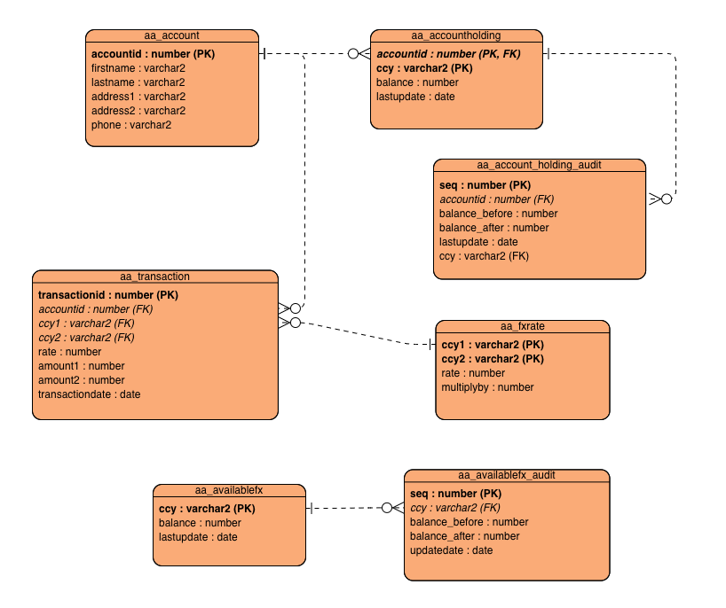

Functions:

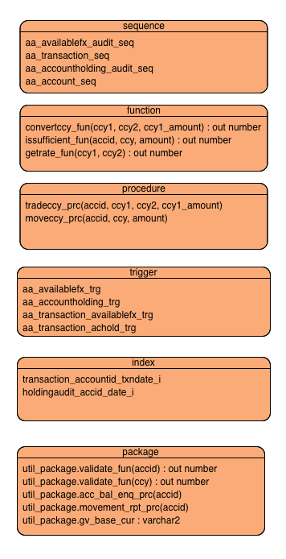

Customer Fx rate ***Enquiry*** (SQL)

Customer account ***Enquiry*** (SQL + function rateConvert)

Customer ***PlaceOrder*** (procedure (insert to transaction table) + ***Trigger*** (update available balance)

***Withdraw*** currency (procedure with overloading)

Night batch ***Clearing*** (procedure update transaction status)

***AuditTrail*** (trigger) → generate a report table (transaction history)

Table:

CustomerAccount

CustomerTransaction

CurrencyRate

AvailableCurrency

AuditTrail

Following are Columns Samples Display:

AA_Transaction:

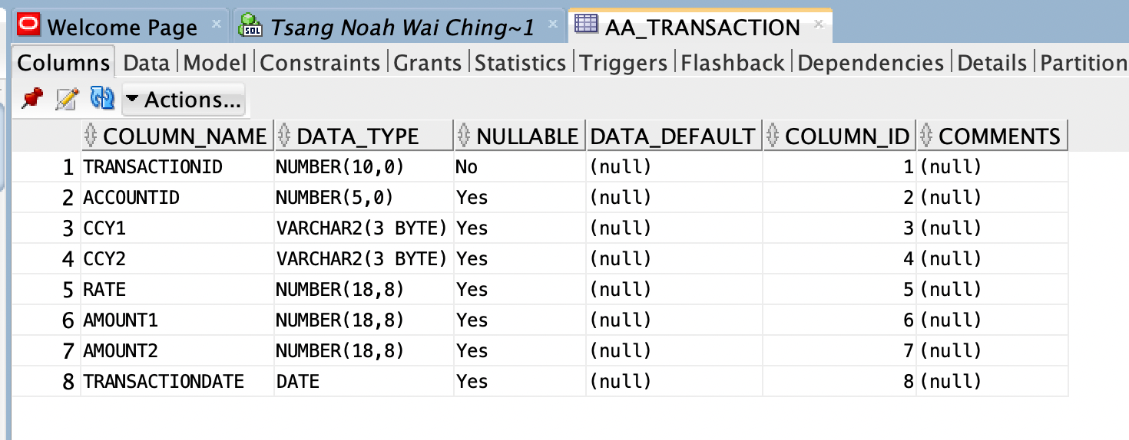

AA_FXRATE:

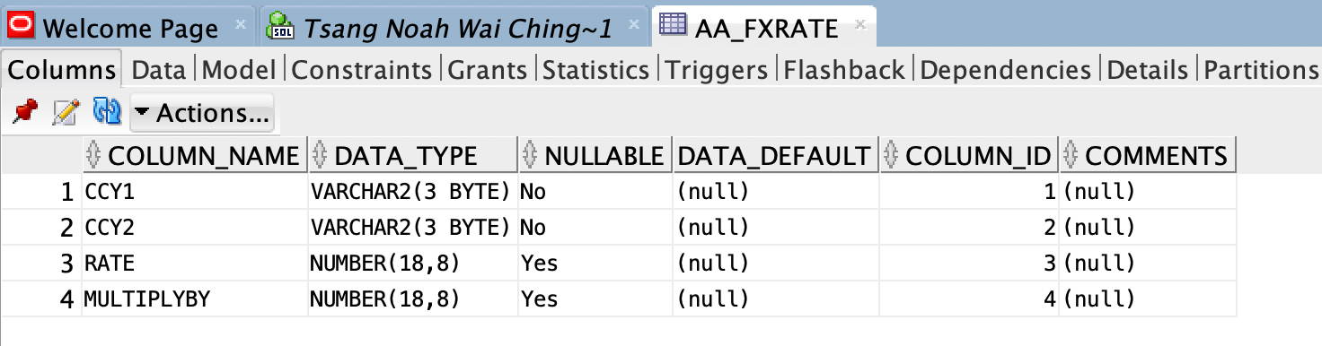

AA_AVAILABLEFX_AUDIT:

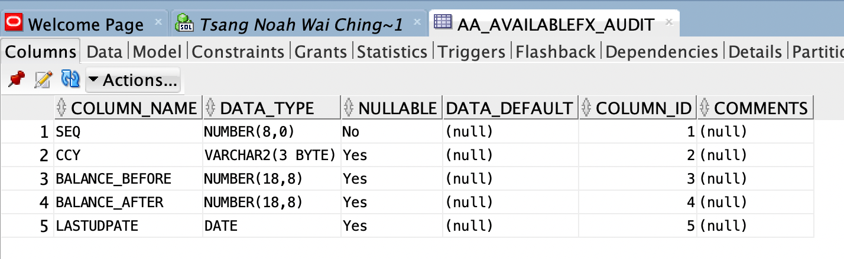

AA_AVAILABLEFX:

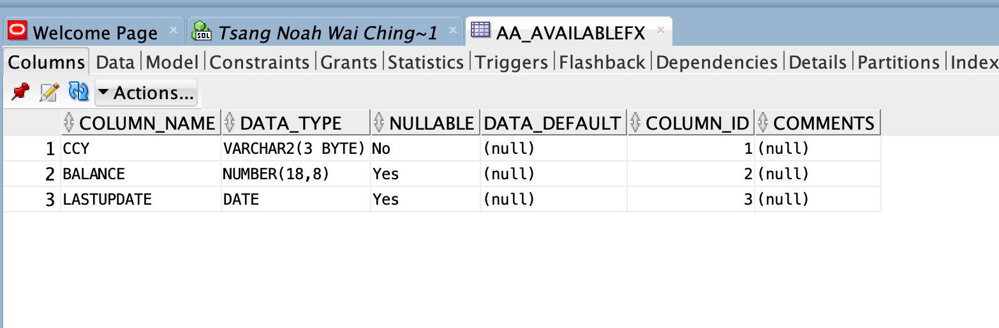

AA_ACCOUNTHOLDING_AUDIT:

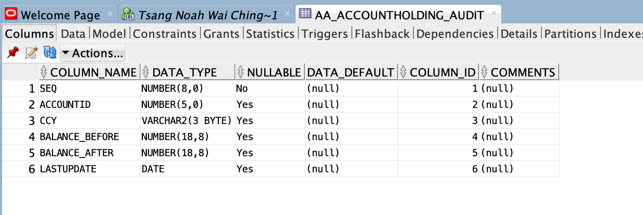

AA_ACCOUNTHOLDING:

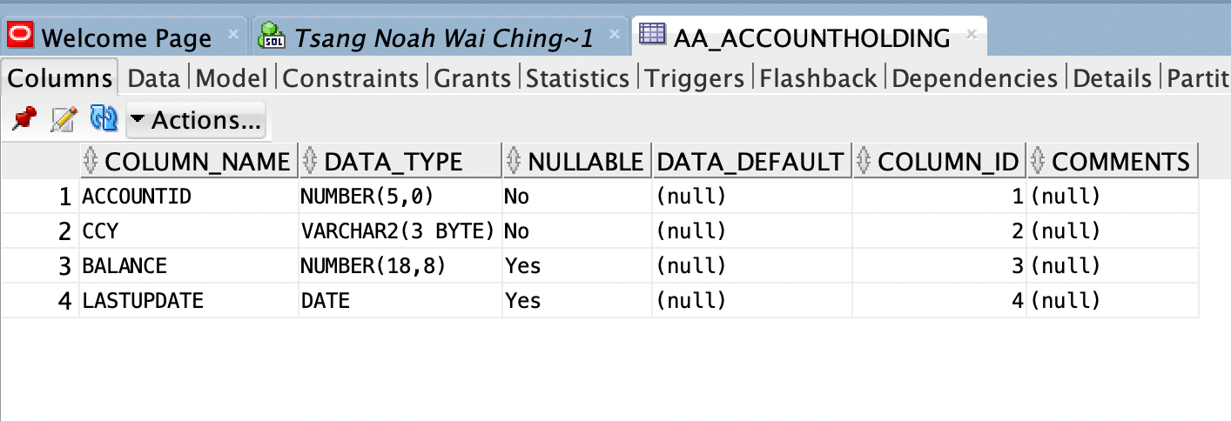

AA_ACCOUNT:

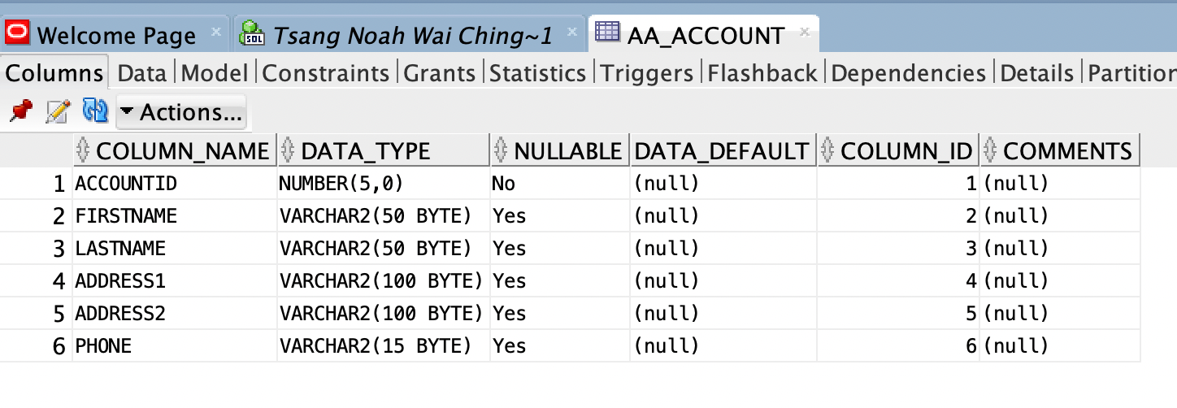

Triggers:

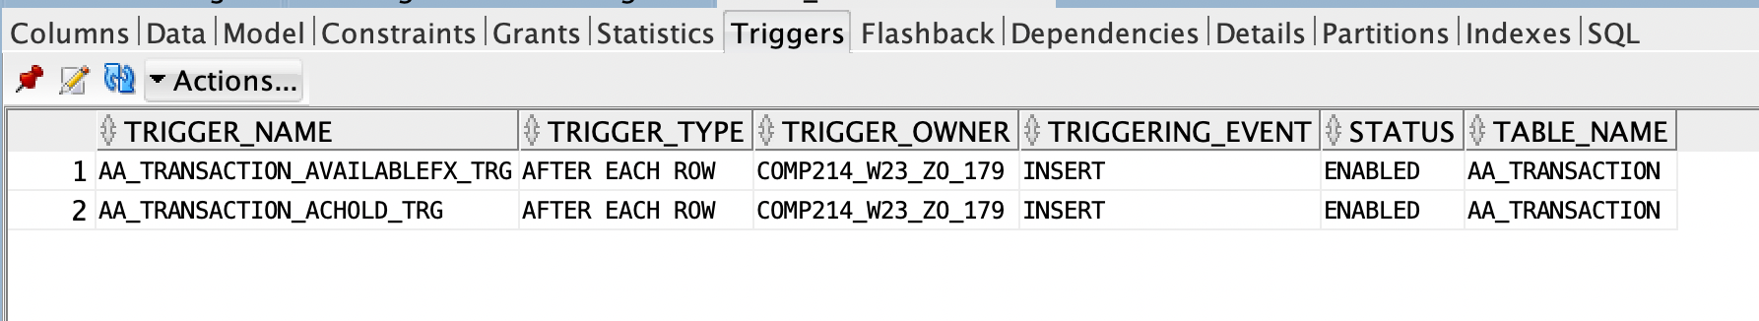

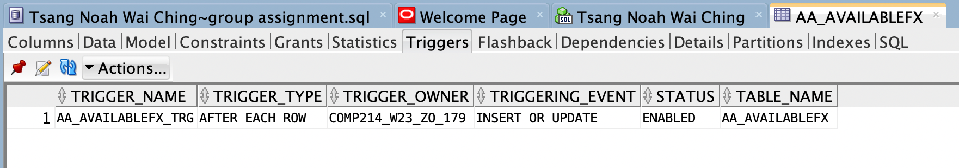

Indexes:

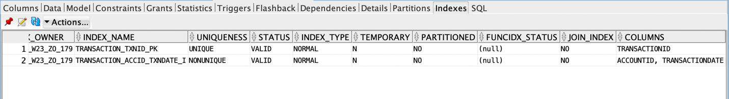



AA_ACCOUNT: Data Display

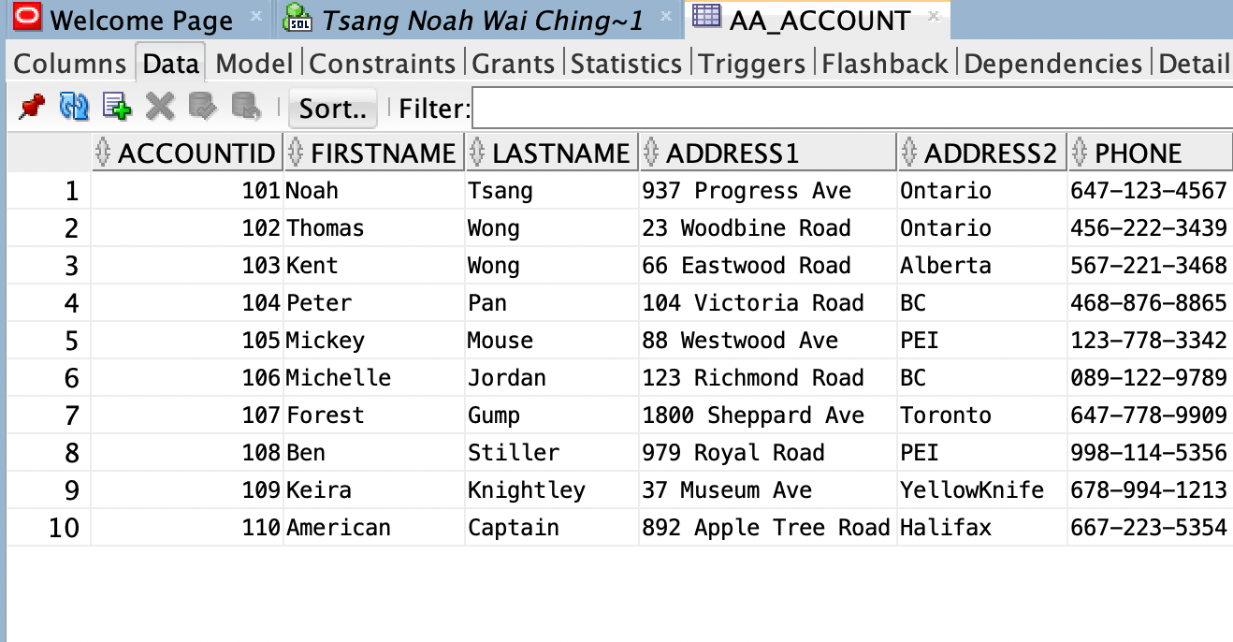

AA_FXRATE: Data Display

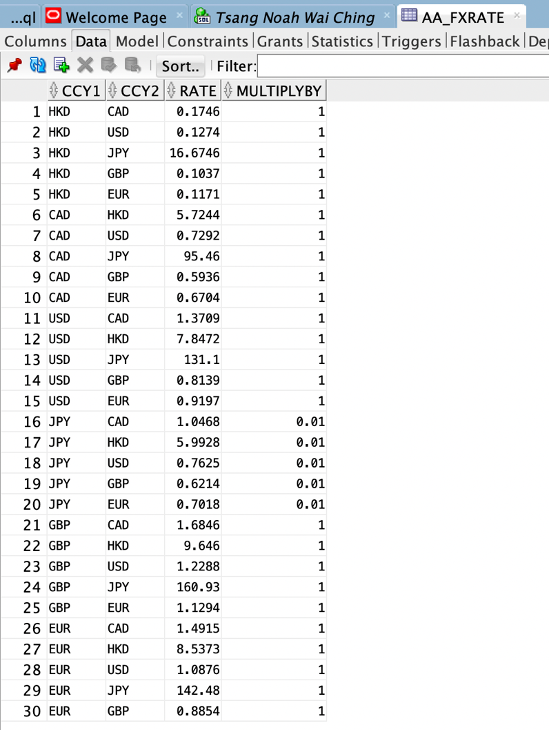

AA_AVAILABLEFX: Data Display

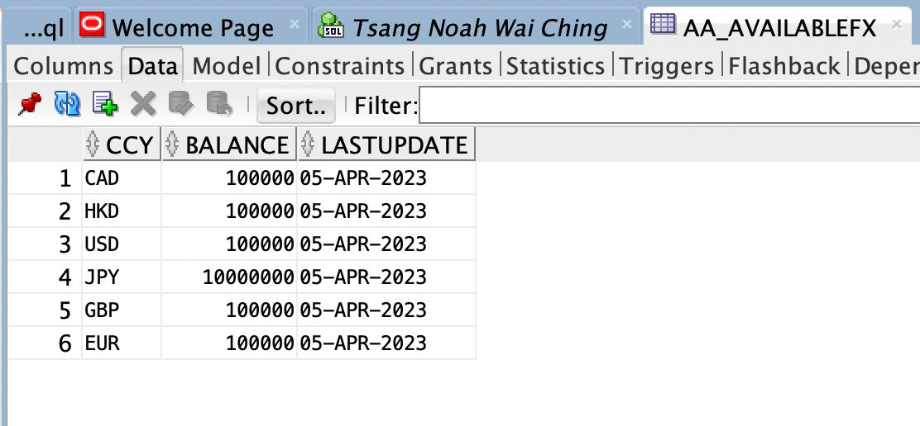

AA_ACCOUNTHOLDING: Procedures, Packages, Functions, Triggers Display

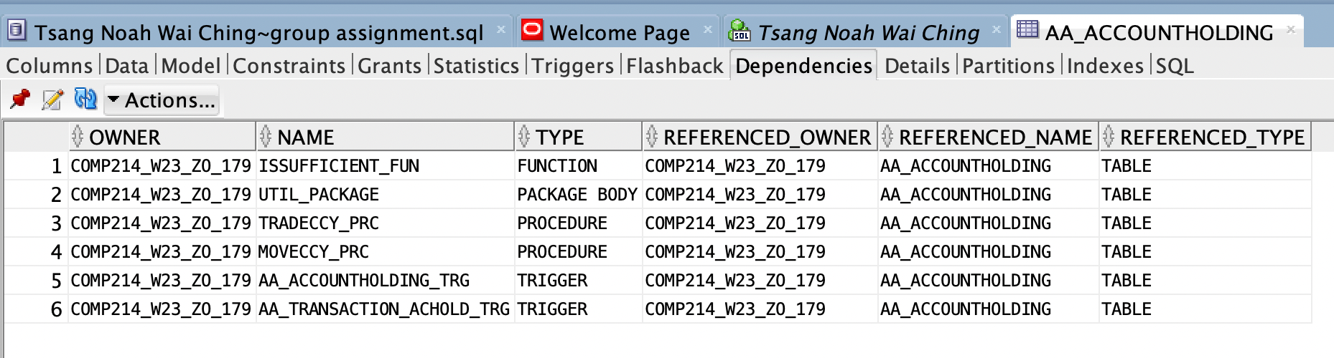

AA_FXRATE: Functions, Procedures, Packages Display

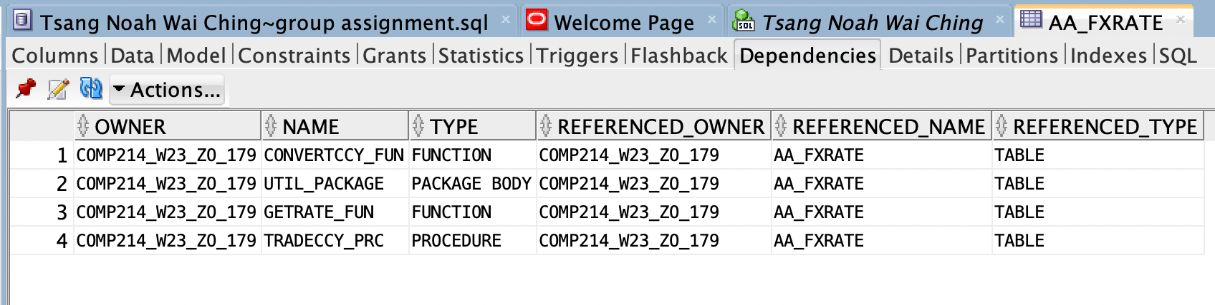

AA_TRANSACTION: Model

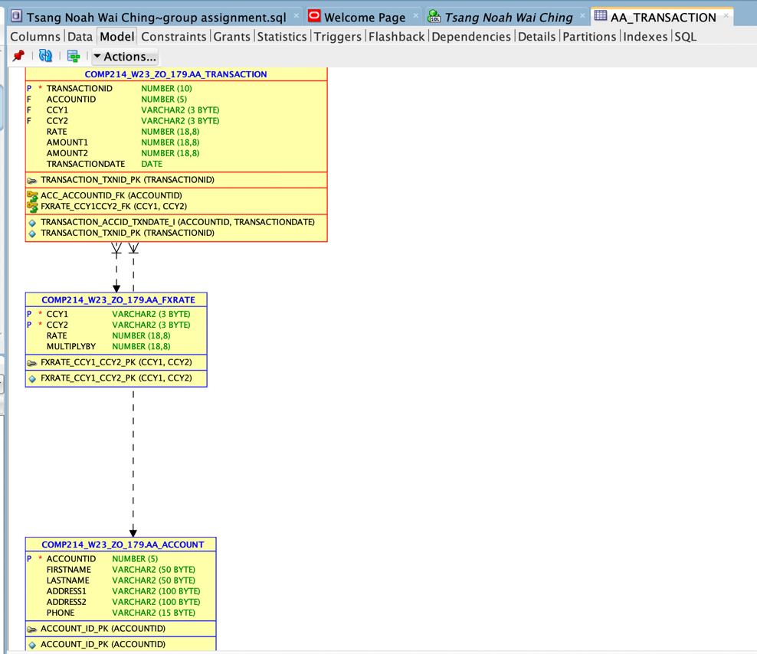

AA_ACCOUNTHOLDING: Model

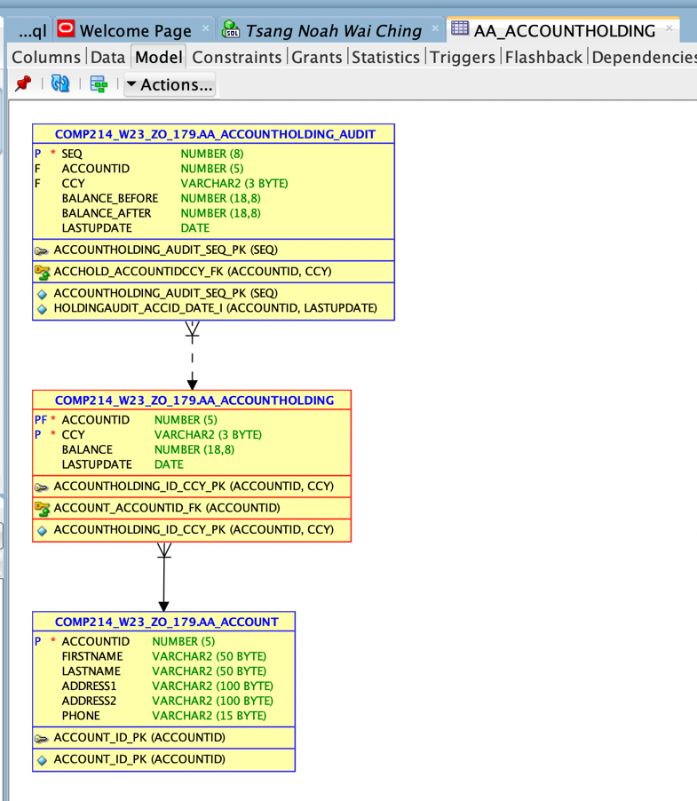

AA_FXRATE: Testing

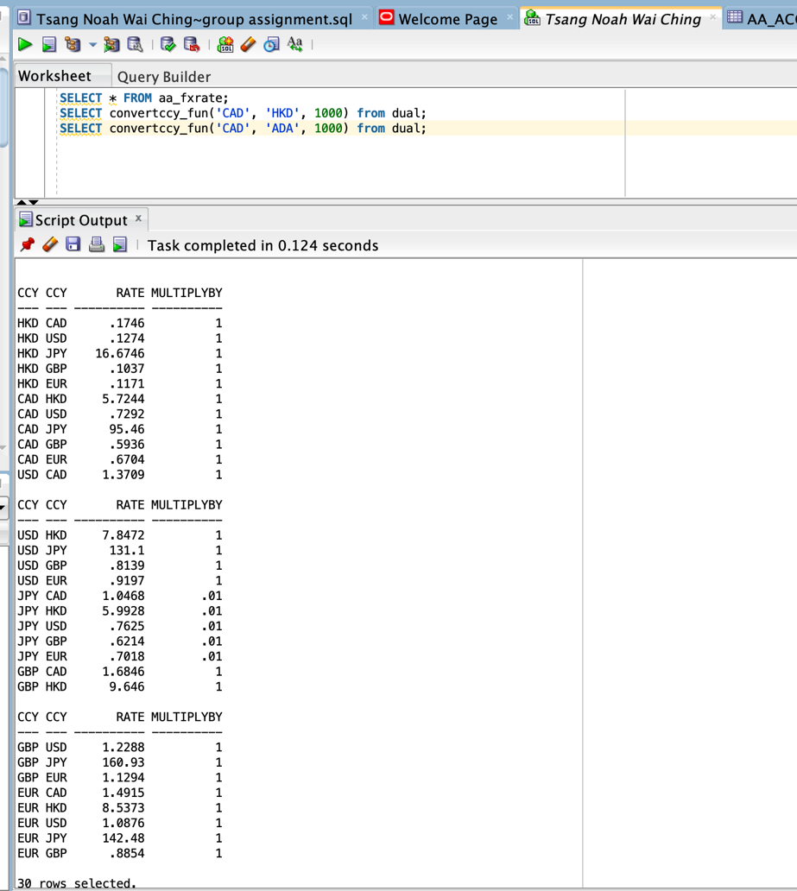

AA_ACCOUNTHOLDING, AA_ACCOUNTHOLDING_AUDIT: Testing

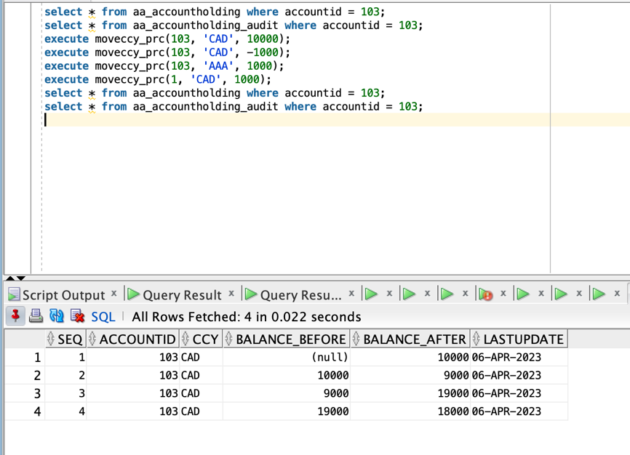

AA_ACCOUNTHOLDING, AA_AVAILABLEFX: Testing

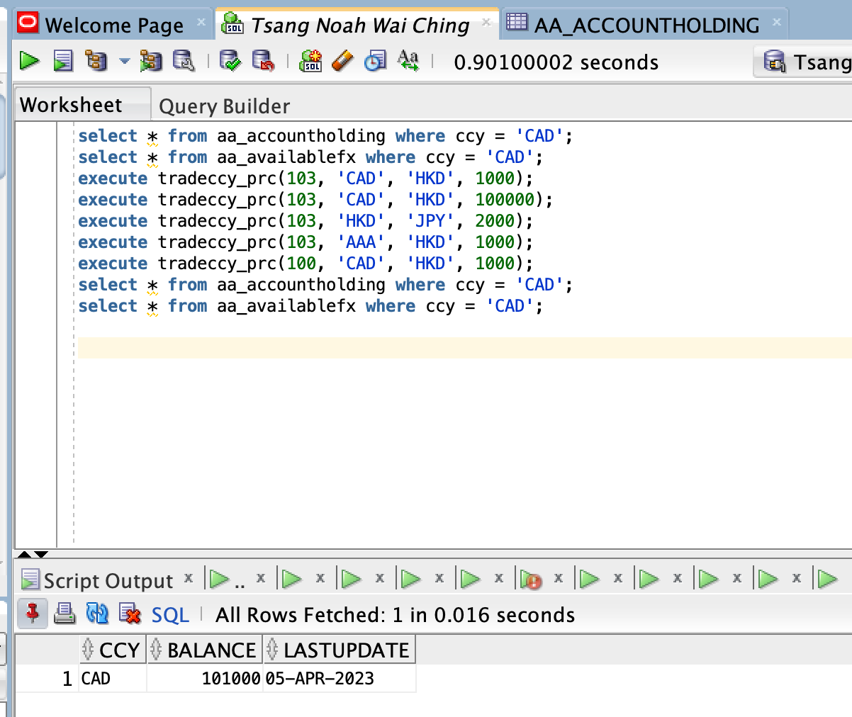

AA_ACOUNTHOLDING_AUDIT: Testing

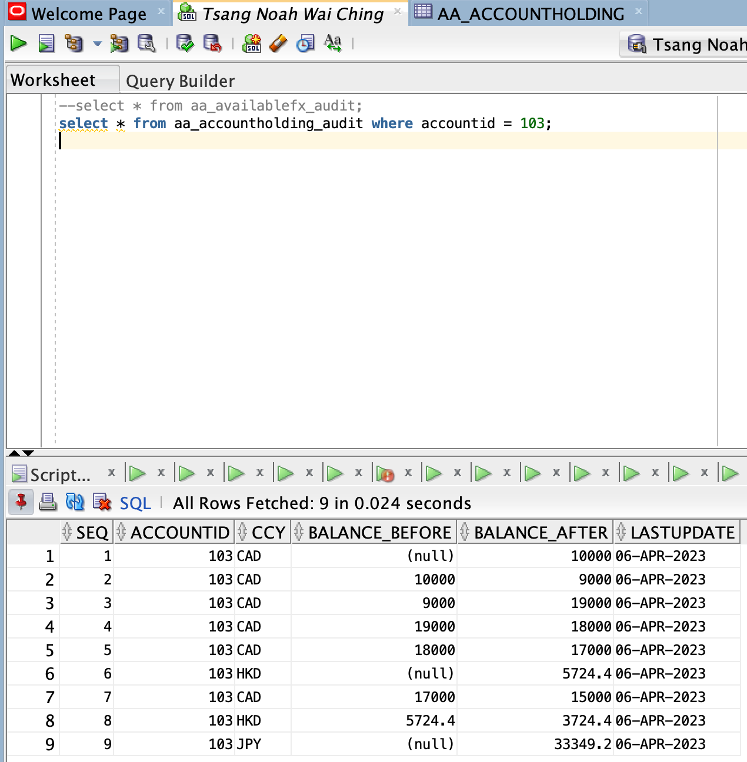

UTIL_PACKAGE: Testing

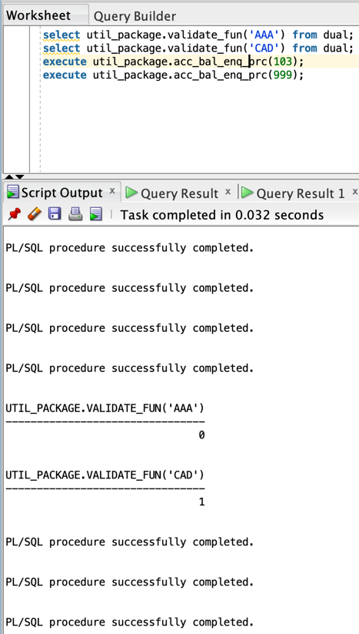

Front End Interface: Trade Currency

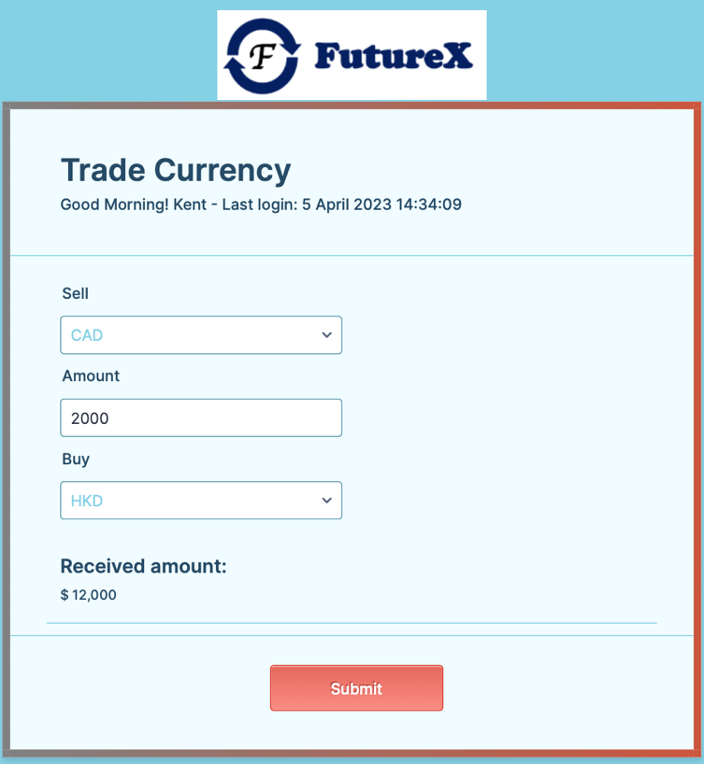

Front End Interface: Account Enquiry

